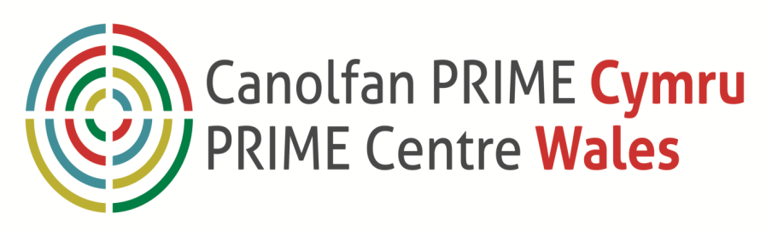

PRIME - SAIL Collaboration

Bid development support for linked data research

Study contact person: [Title, Name]

Position in PRIME: [Role and title if applicable]

Contact details: [Email, Telephone]

Organisation: [Name and Address]

Date of request: [Date]

Request for SAIL support

[Please complete where applicable]

- Request type: Support Bid Development for Linked Health Data Research

[Please select below]

Proposed funding source | Submission deadline | Proposed start date
[Name] | [Date] | [Date]

Research team members

Name | Role | Responsibilities

- Request type: Support Dissemination and Impact of Linked Health Data Research

Expected outputs | Proposed submission date
[Journal paper, Seminars, Conference events, alternative outputs] | [Date]

- Request type: SAIL Data Access Query

Information governance | Data type
[Please state required support] | [data source, variables, size, volume, case mix, completeness]

- Request type: Other

[Please state below]

Project/Trial Proposal

Project/trial title

Project/trial outline
[Aims/objectives and expected outcomes]

SAIL scoping support
[Feasibility of study/data query support]

Additional information

Please return completed form to:

Name | Ashra Khanom
Address | Swansea University Medical School, ILS 2, Floor 2, Swansea University, Singleton Park, Swansea, SA2 8PP.
Email | a.khanom@swansea.ac.uk
Telephone | 01792 606649

We will aim to respond to your queries within 14 days

