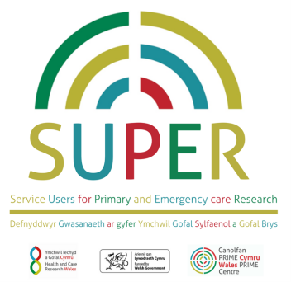
Summary of research development information for SUPER members
Contact name
Role and organisation
Contact email address
Name or working title of research bid (acronym and in full)
Chief investigator
Person presenting to SUPER meeting
Brief description of proposed research (approx. 250 words)
How do you plan to involve public members and patients in the proposed study?
What questions or aspects of your research do you want SUPER to consider?
Target research grant and timetable OR grant details if funding already awarded
Date this form was completed

Please return to Angharad Claydon: a.a.claydon@swansea.ac.uk

