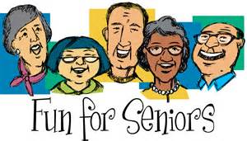
NEWSLETTER

3Cs over 65s Club at Beddau Library
Companionship, Conversation and Creativity

BACKGROUND – Beddau Library was successful in gaining funding from VAMT Community Capacity Fund, to run a group specifically for local senior citizens. Since October 2015 the group have met every Monday morning from 10.30-12.30.
The programme is coordinated by
Mair Williams and assisted by
Rhian Baddeley. The aim of the group is to encourage friendships in and outside the group, give older people confidence in meeting new people, empowerment to find out about services that they can access, revive their interest in new topics/hobbies. All facilitators and guest speakers are qualified and experienced in their subject.
Different workshops give you something else to think and talk about!
It’s nice to have somewhere to drop-in

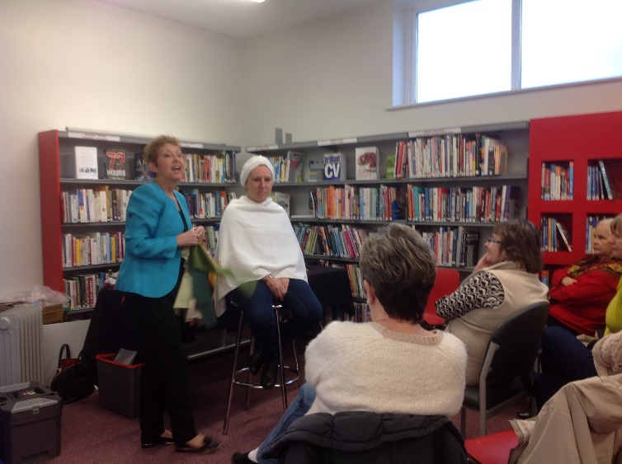
To date 30 senior citizens of 65 years plus and an additional 5 senior citizens of 60 years plus have enjoyed taking part in these FREE weekly workshops.
Emergency First Aid

Pampering and colour your personality
WHAT’S TAKEN PLACE SO FAR?
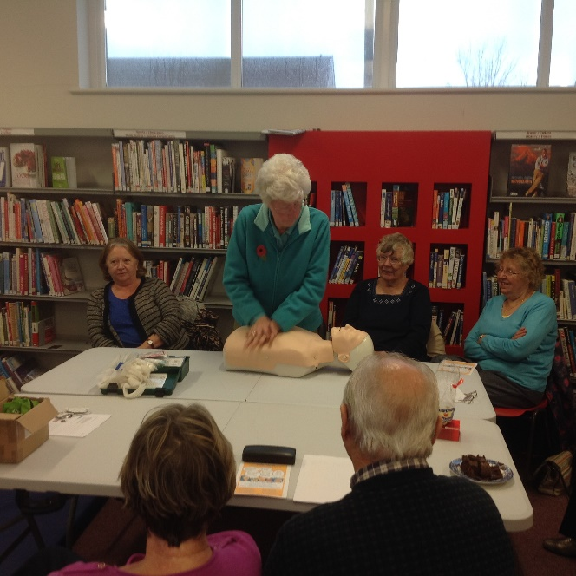

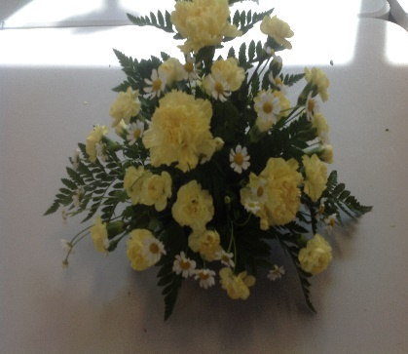
I always know what I’m doing on a Monday
Flower Arranging
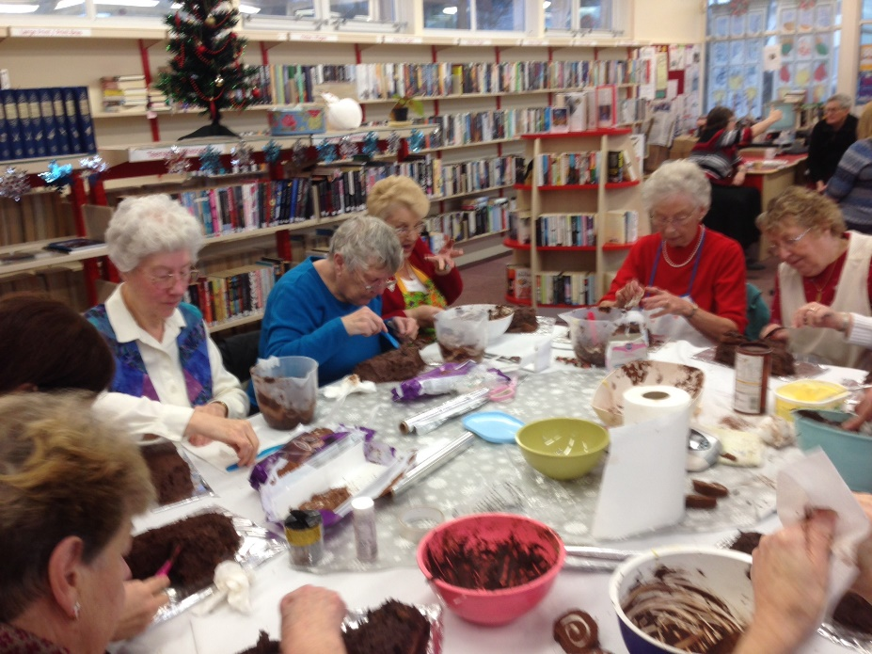
Pottery
Attending 3Cs has improved my confidence in meeting new people
Cake Decorating
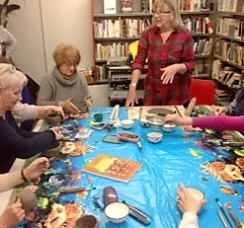
Nice that there is no need to prepare for the group, unlike some group courses

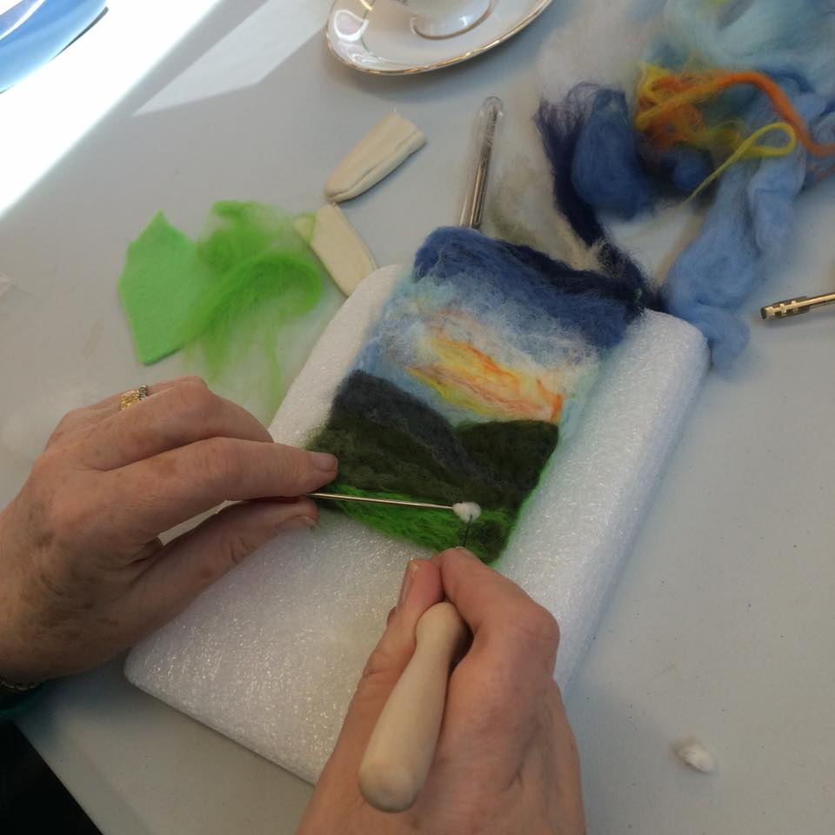

Pottery

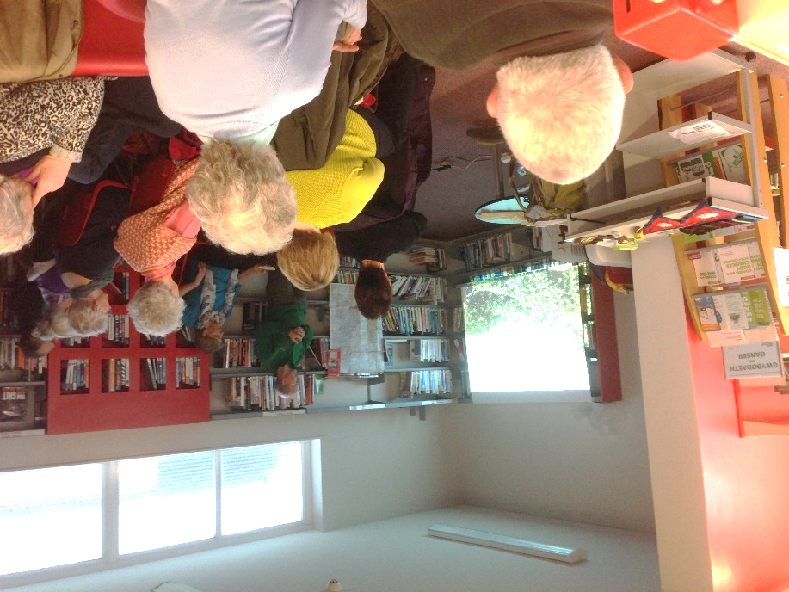
Guest Speakers
Painting with Felt

An inspirational guest speaker – Everest Trip

WHAT’S NEXT?
- Welcome new members!
- To look for new funding for 2016 in order to continue the programme.
- To develop new and interesting workshops that will encourage more men to attend.

For more information, call Mair Williams on 07934375936
FUNDED THROUGH THE COMMUNITY CAPACITY FUND

