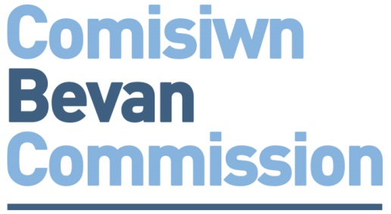

APPLICATION FORM – for ALL Bevan Exemplars

Completed forms should be submitted by email to your local Health Board/Trust Lead – contact details at the rear of this form.

We encourage applications from NHS organisations and non-NHS organisations where is a positive health impact.

Personal Details
Job Title
Forename
Surname
Phone Number(s)
Email(s)
Twitter Handle
Organisation
Department/Section
Base

Line Manager’s Details
Job Title
Forename
Surname
Department
Phone Number(s)
Email(s)

Give your idea a title

Briefly describe your idea
[Guide length – 300 words]

What Contribution will you make to Prudent Healthcare?
- Achieve health and well being with the public, patients and professionals as equal partners through co-production.
How will you involve patients and/or the public in the design and delivery of your project?
[Guide length – 150 words]

- Care for those with the greatest health need first, making the most effective use of all skills and resources.
[Guide length – 150 words]

- Do only what is needed, no more, no less; and do no harm.
[Guide length – 150 words]

- Reduce inappropriate variation using evidence based practices consistently and transparently
[Guide length – 150 words]

Plans
[Outline your plans for delivery here. What will you do? When will you do it?]

Anticipated Benefits / Outcomes / Results
[List how your idea might benefit the health of the people in Wales and/or NHS Wales, e.g. improved healthcare outcomes, improved patient experience, resource efficiency etc.]
[Guide length – 250 words]

Evaluation
[Describe how you will measure your idea’s anticipated impact / benefits / outcomes / results]
[Guide length – 250 words]

Additional Information for Health Technology Exemplars ONLY

Health Technology Applications only – Industry Partner Details
Job Title
Forename
Surname
Department
Phone Number(s)
Email(s)

Health Technology Applications only – Funding & Resources
Contribution agreed with LHB/Trust:

Contribution agreed with Technology / Industry Partner:

Funding contribution required from the Bevan Commission:

Health Technology Applications only – Commercial Arrangements
[Briefly describe any commercial arrangements]
[Guide length – 250 words]

Commitments Please Tick to Confirm
I commit to participating fully in the Exemplars’ programme of networking events (up to 6 days)
I commit to delivering my project within 9-12 months
I commit to promoting my participation in the Bevan Commission Exemplars and the outcomes and learning from my project
I commit to preparing an evaluation of the my idea

Completed forms should be submitted by email to your local

Health Board/Trust Lead:
Organisation | Lead | Lead Email
Abertawe Bro Morgannwg UHB | Christine Morrell | christine.morrell@wales.nhs.uk
Aneurin Bevan UHB | David Thomas | david.thomas15@wales.nhs.uk
Betsi Cadwaldr UHB | Adrian Thomas  Lynne Grundy | adrian.thomas@wales.nhs.uk  lynne.Grundy@wales.nhs.uk
Cardiff and Vale UHB | Abigail Harris  Robyn Davies | abigail.harris@wales.nhs.uk  robyn.davies5@wales.nhs.uk
Cwm Taf UHB | Tom Powell | thomas.powell2@wales.nhs.uk
Hywel Dda UHB | Phil Kloer | philip.kloer@wales.nhs.uk
Powys Teaching Health Board | Howard Cooper | howard.cooper@wales.nhs.uk
Public Health Wales NHS Trust | Rhiannon Beaumont-Wood | Rhiannon.Beaumont-Wood@wales.nhs.uk
Velindre NHS Trust | Phil Webb | philip.webb@wales.nhs.uk
Welsh Ambulance Services NHS Trust | Grayham Mclean | grayham.mclean@wales.nhs.uk
NWIS | Wendy Dearing | wendy.dearing@wales.nhs.uk

