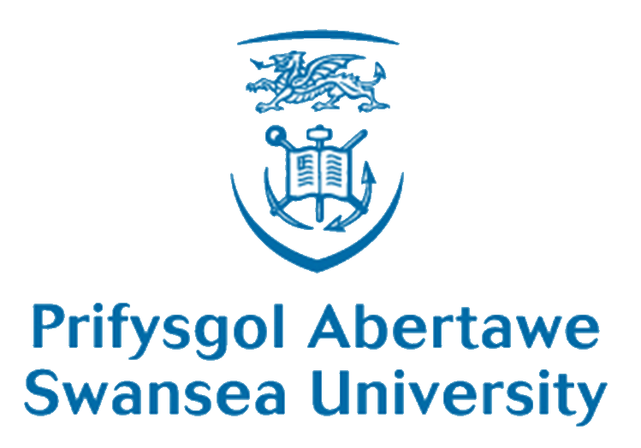

All-Wales Medical and Dental Education Conference

‘Inspiring a sustainable health workforce for Wales’
Wednesday 13th April 2016, 9.30am – 4.30pm
Education Centre, Morriston Hospital, Swansea, SA6 6NL
Abstract Deadline: 5th February 2016

Abstract Submission Form

Name (of presenting author): | Title:  First name:  Family name:
Institutional Affiliation

Address for correspondence
(of presenting author, including postcode)
E-mail (of presenting author):
Phone No
I would prefer (please tick):
Oral presentation (15 minutes)
Poster
In order of priority (1,2,3,4,5,6,7) please indicate which theme/session best fits your presentation/poster
Welsh Language, Rural Health and Culture
Recruitment and Retention
Interprofessional Education
The Welsh Workforce for Health
The Learning Environment
Innovation
Assessment & Feedback
Abstract Submission

Abstracts must be submitted by e-mail (mededconference2016@swansea.ac.uk) using this form.
Please start the email subject/title with the words ‘MEDEDCONF ABSTRACT 16’.
All abstracts must be submitted and presented in English.
All submitted abstracts will be evaluated by the Programme Committee and authors will be notified regarding acceptance and form of presentation by early March.
Please note, we have a limited number of oral presentation slots but can offer unlimited poster boards. Poster viewing will be at the morning break and lunchtime.
Please prepare your abstract(s) using the following format in the box below
Font: Arial 12 point
Title
(in bold)
Name(s) of the author(s), titles and affiliations
Abstract text should not exceed 400 words

Use these headings:

Background/context
What we did and why
What we found
Key messages
References

