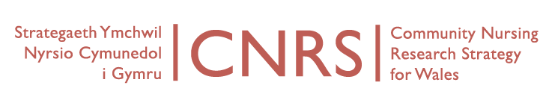
Wednesday, 29th April, 10-12
Board Meeting
Venue: University of South Wales, Aneurin Bevan Building, Room AB115, Lower Glyn Taf Campus, Pontypridd CF37 1DL.
Directions: http://findaroom.southwales.ac.uk/rooms/gtab115
Video conferencing IP address: 194.83.178.242
AGENDA
Video conferencing attendees: Marie Lewis (Powys tHB), Deborah Roberts (Glyndwr), Caroline Williams & Chris Hayes, Associate Director of Nursing (Hywel Dda)
Apologies: Marie Bodycombe-James (Swansea), Judith Carrier (CU), Greg McKenzie (Cwm Taf HB), David Hopkins (NHS Wales Informatics Service; Anne Owen attending in place of), Jane Imperator (Cardiff & Vale NHS), Neil James (USW), Maggie Kirk (USW), Nicola Lewis (ABM ULHB), Paul Labourne (Powys tHB), Ruth Lawler (PHW), Nicola Lewis (ABM ULHB), Ruth Northway (USW), Joanne Pike (Glyndwr), Jayne Sankey (BCUHB), Denise Watkins (Cardiff University)
- Welcome and Introductions (Apologies)
- Notes of last meeting held 14th January 2015
- Matters arising
- Framework for collaboration
- Report on Coordinator activity this quarter (CW)
- Marketing
- CNRS updates
  - CNRS Portfolio Studies
  - Developing Industry Research
  - Bevan Commission
  - WONCA Dubrovnik / Istanbul / ICCRN conference Seoul
- Future projects or Collaborations
  - Frailty
  - Tender Public Health Wales
- CNRS Research themes and leads:
  - Organisational change and service redesign
  - Nursing roles
  - Skill mix
  - Evidence and outcomes
  - Education and development
  - Long-term care
  - Occupational health
  - Patient safety
  - Patient and user perspectives
- Link with leading areas in new Centre (Wales Centre for Primary & Emergency Care Research)
- Next CNRS conference – 2016 (bi-annual)
- AOB
- Dates of next meetings
  - Wed 15th July 2015, Room 0.15, Cochrane Building, Heath Park, Cardiff University.
  - Wed 14th October 2015, venue to be confirmed.

